Name : Sakthi Manoj R Reg No : 192324236
PROGRAM 10
Create and Explore a Data Frame with Student Examination Data
Aim:
To create and explore a data frame exam_data with name, score, attempts, and qualifying fields, and perform extraction, row/column addition, sorting, and file saving.
Procedure:
Step 1: Open RStudio or R console on your system.
Step 2: Create a data frame with student details such as name, score, attempts, and qualification status.
Step 3: Add a new student record to the existing data frame using the rbind function.
Step 4: Add a new column named grade to assign grades for each student.
Step 5: Arrange the data in descending order based on the score column.
Step 6: Save the final data frame as a CSV file using the write.csv function.
Step 7: Print the data frame to display the updated and sorted student information.
Output :
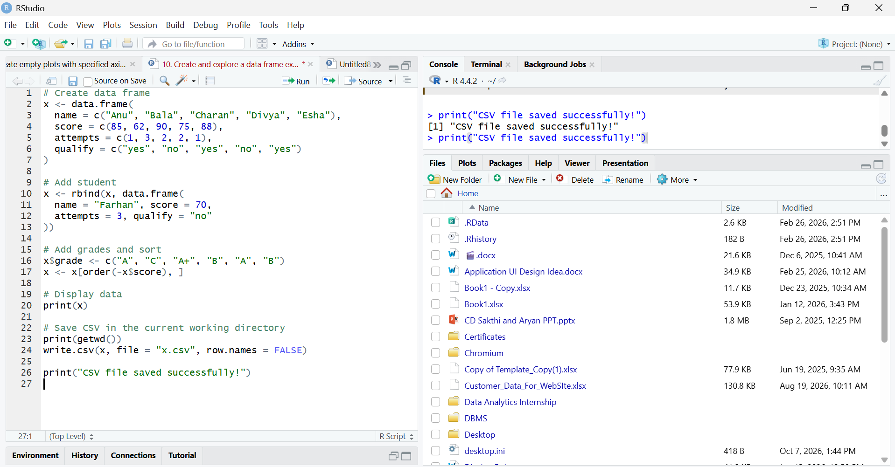
Result:
Hence the output is verified successfully.

